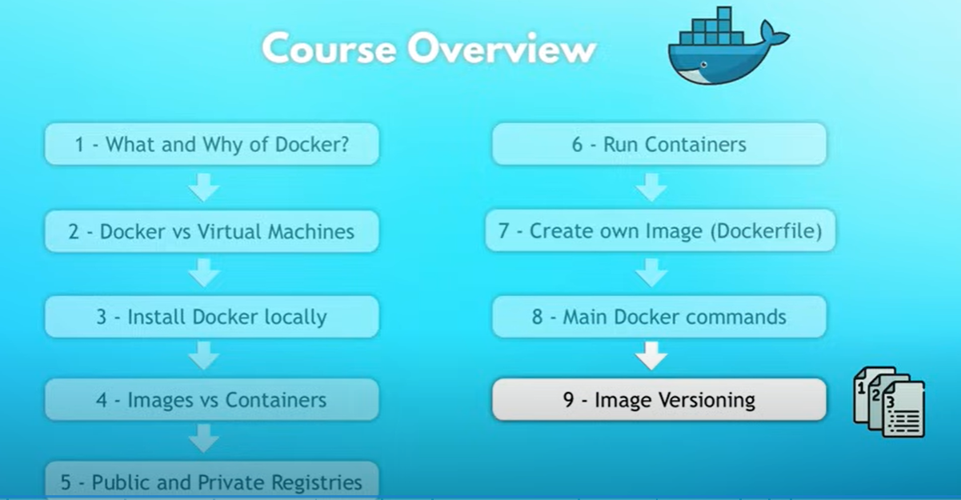

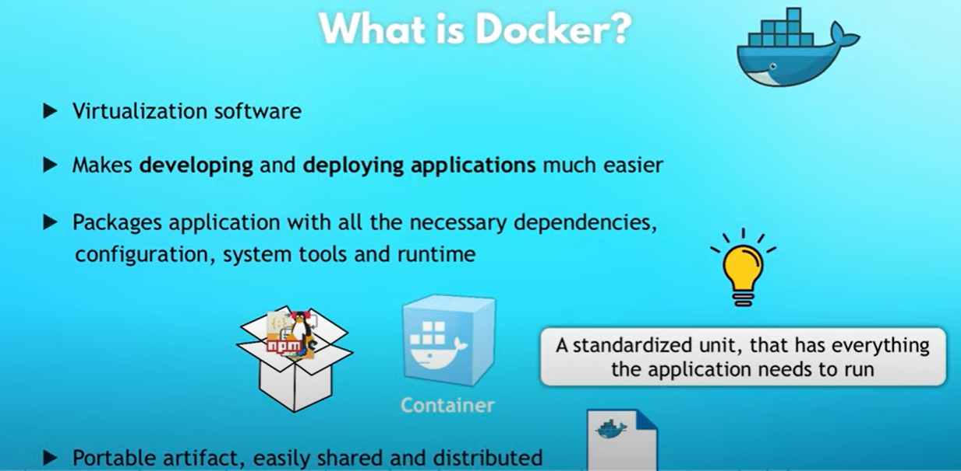

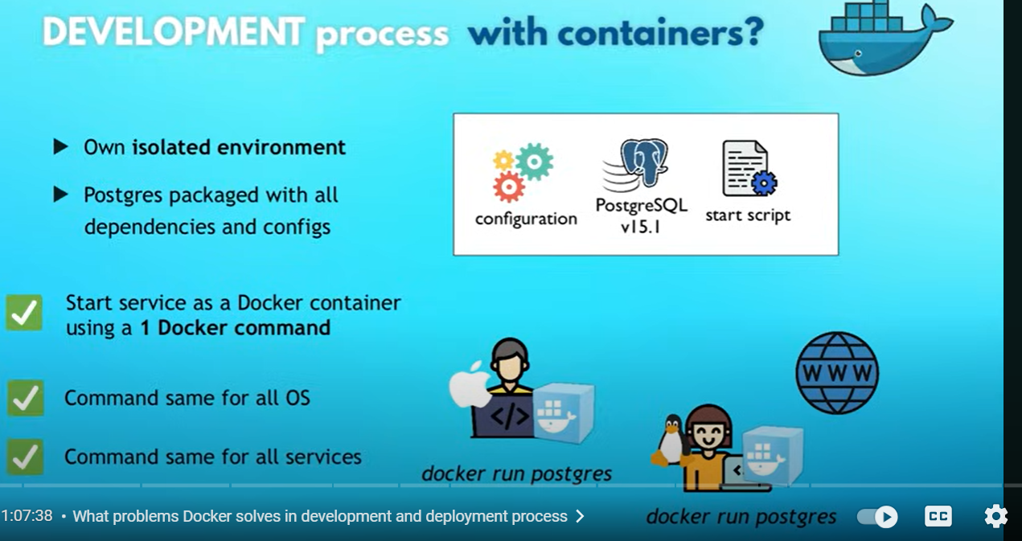

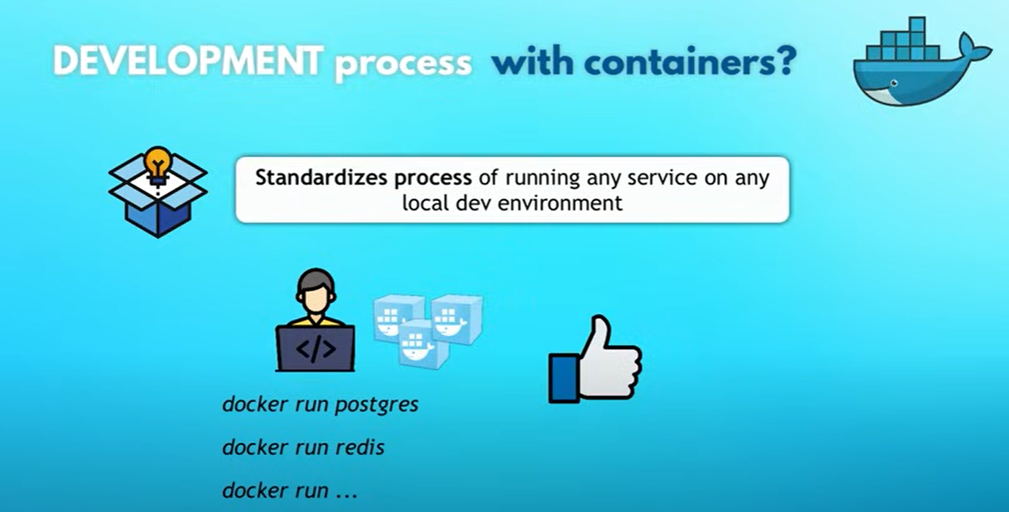

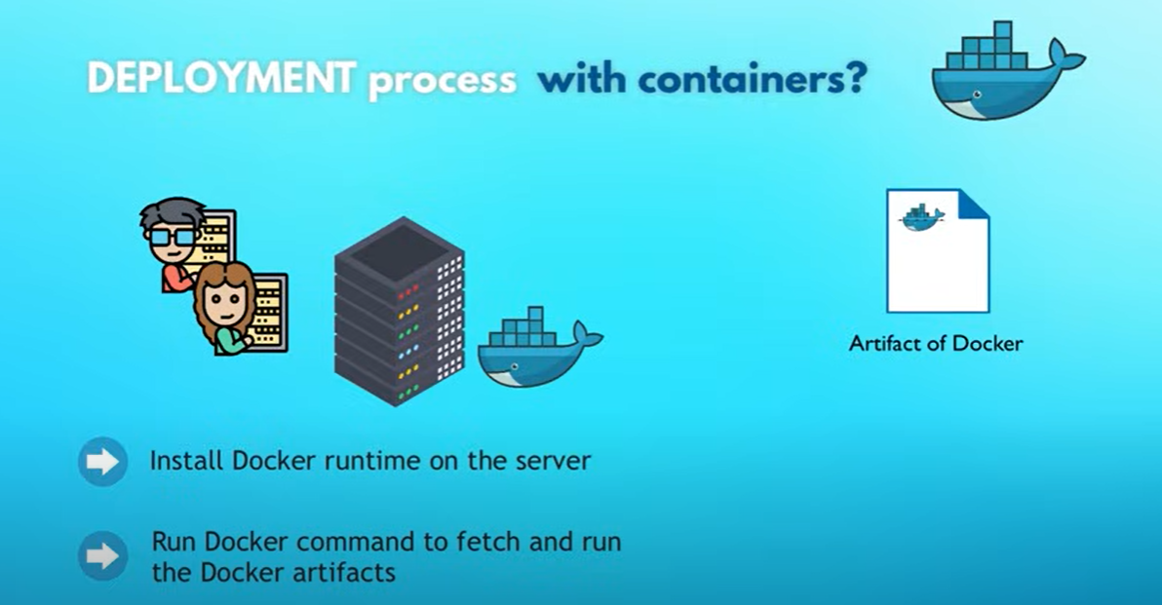

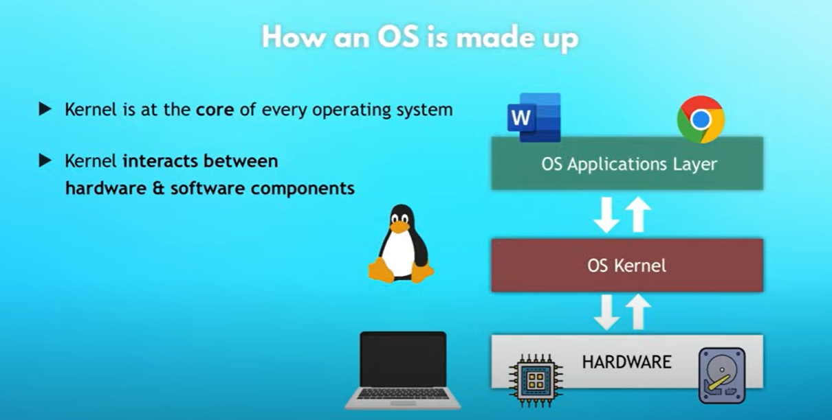

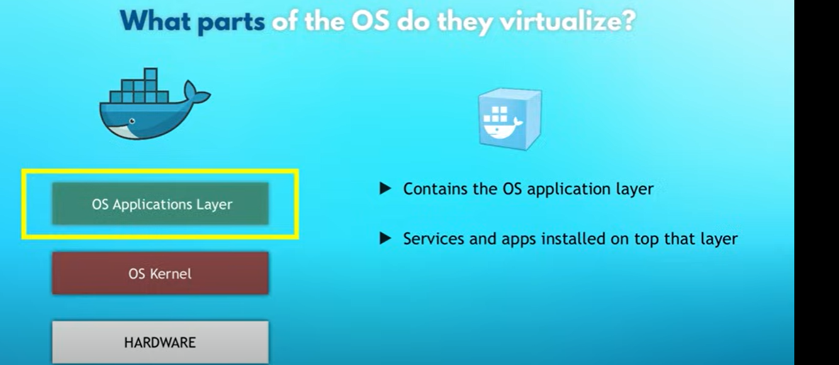

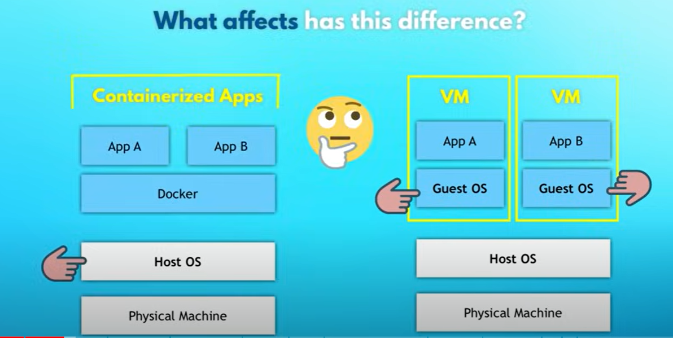

* Docker Desktop includes
* Docker Engine and its Deamon process “dockerd” (manages images and containers)
* Docker CLI

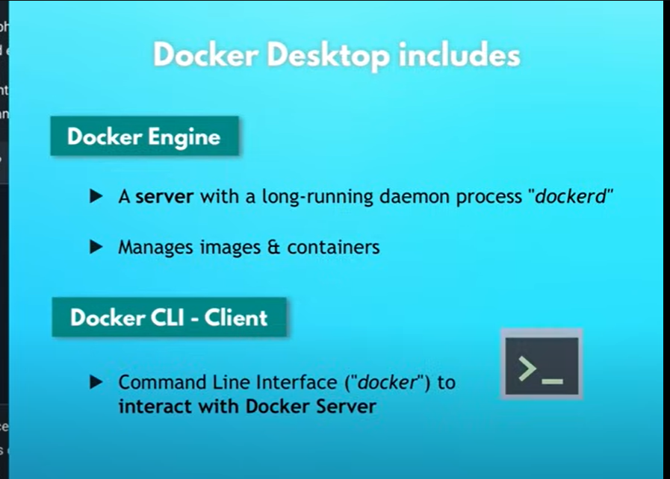

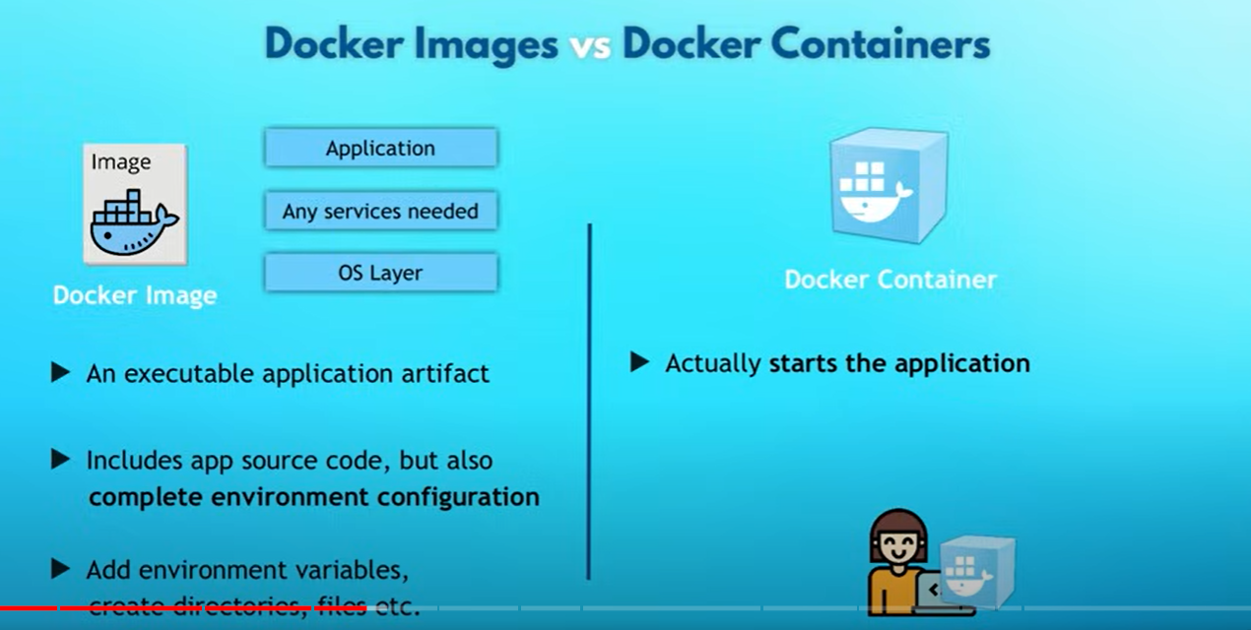

Docker Registries:

Here we need to understand two things,

* All official docker images made available for every body know as Docker Public Registries and the other is Docker Private Registries which will accessible for only selected, example for both public and private registries are like Docker Hub, ACR etc.
* Here in every Public/Private Docker registries we have multiple versions of same application images, database images etc…, these are bifurcated into different “Repositories” with in docker registry and also you can store public and and private repositories as shown below

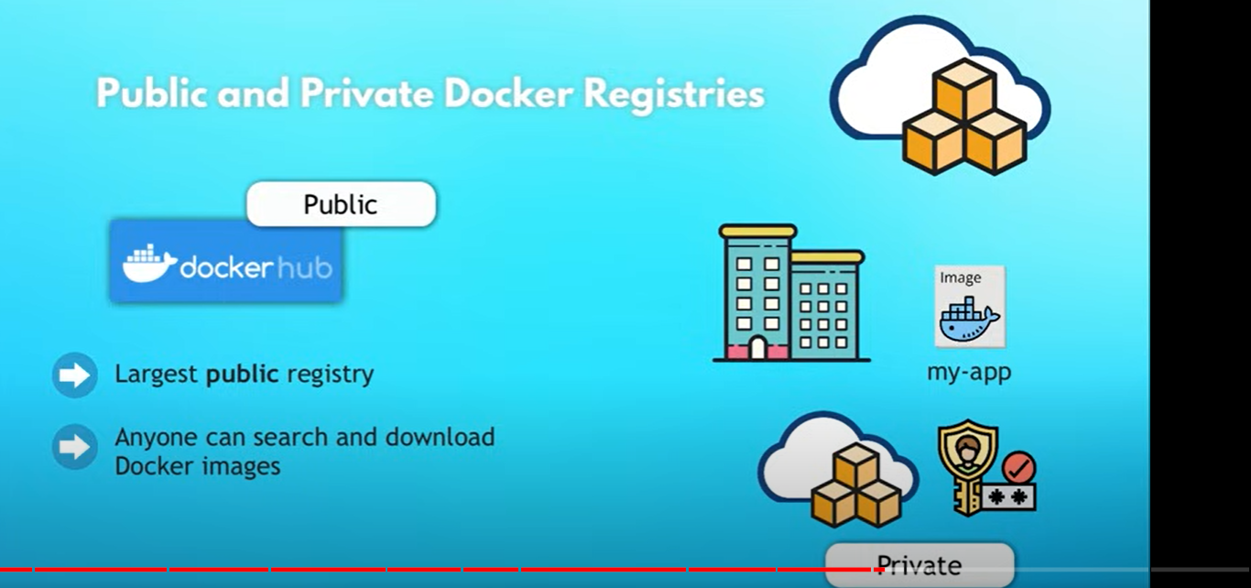

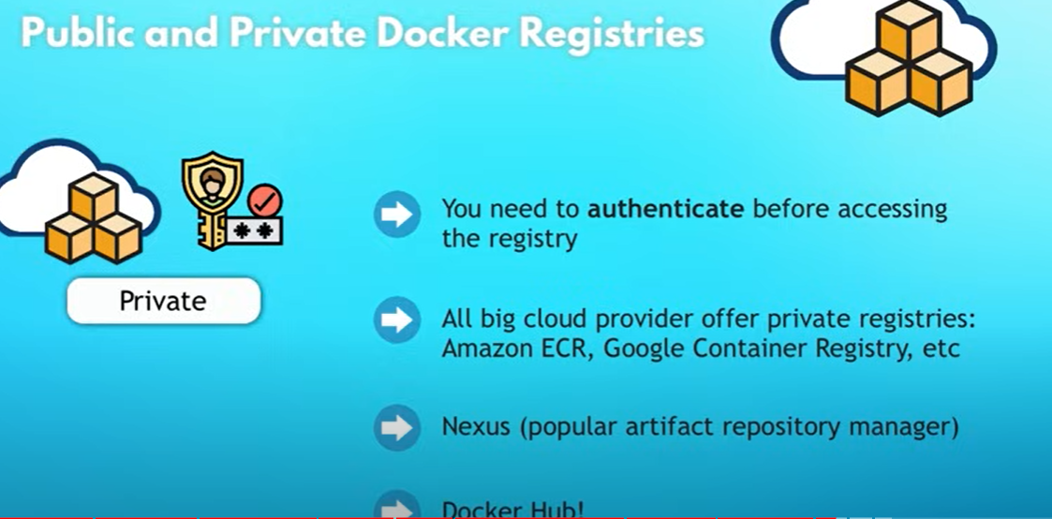

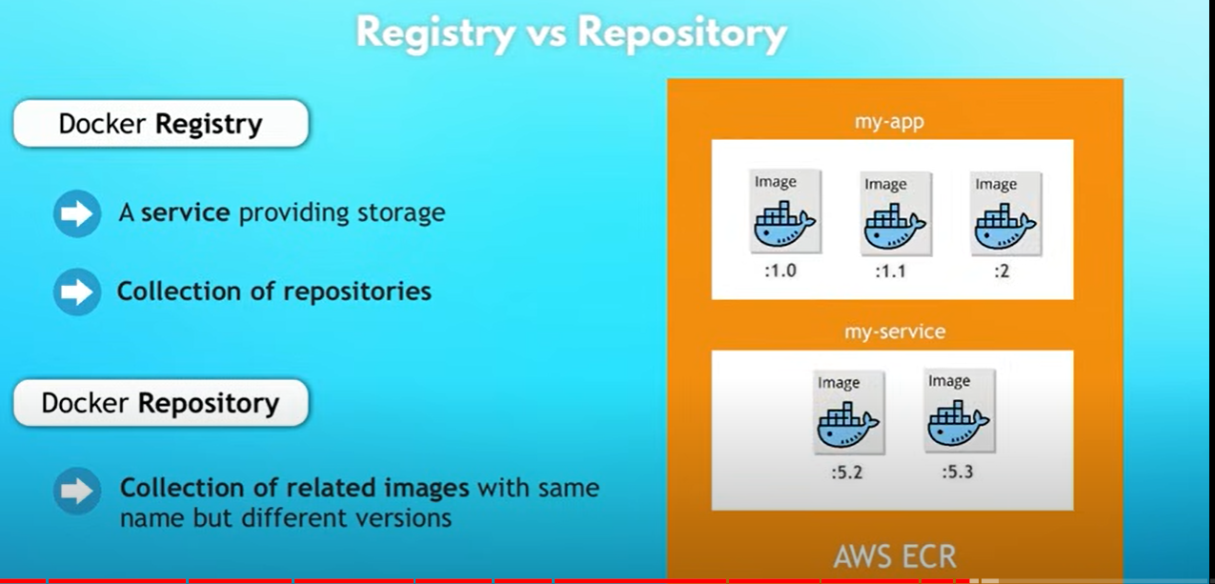

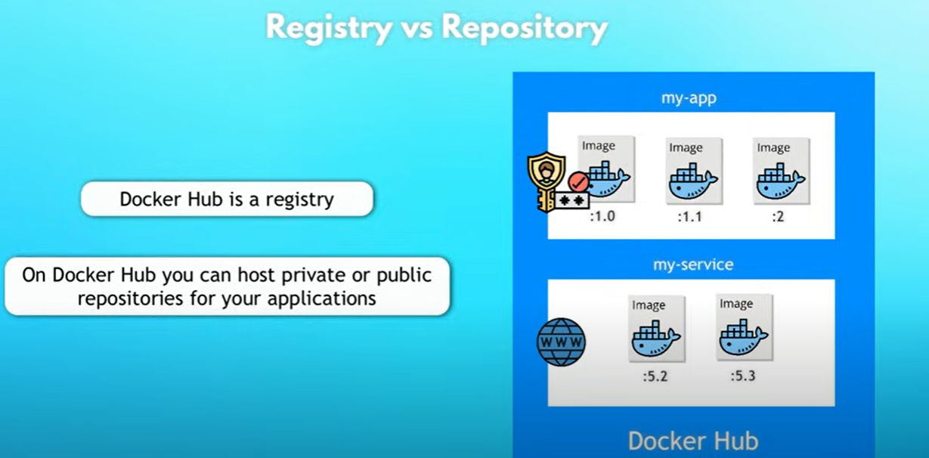

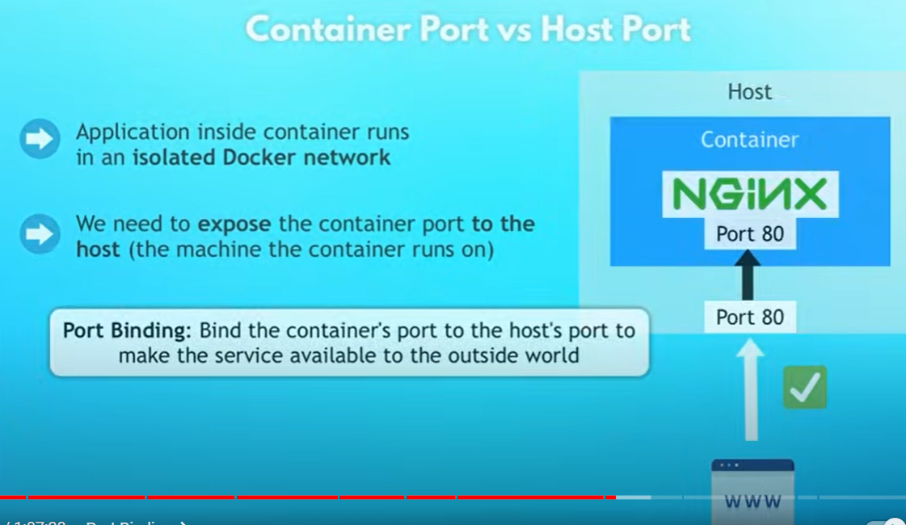

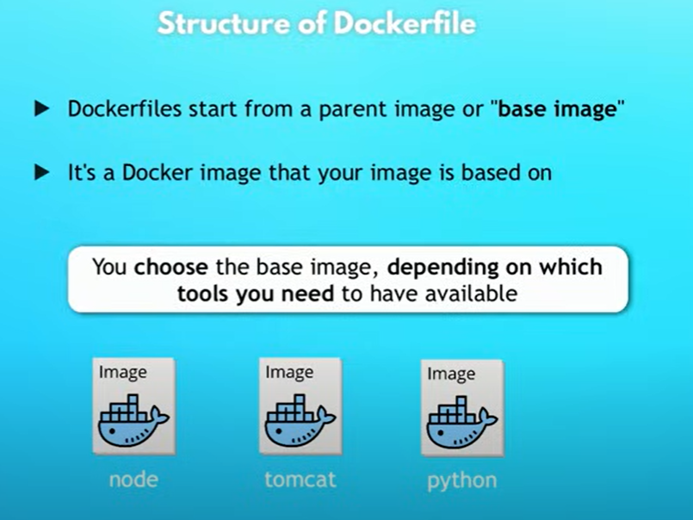

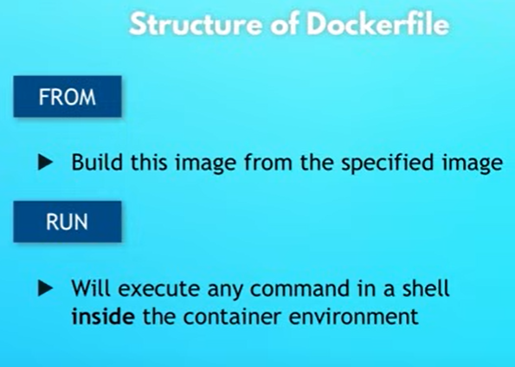



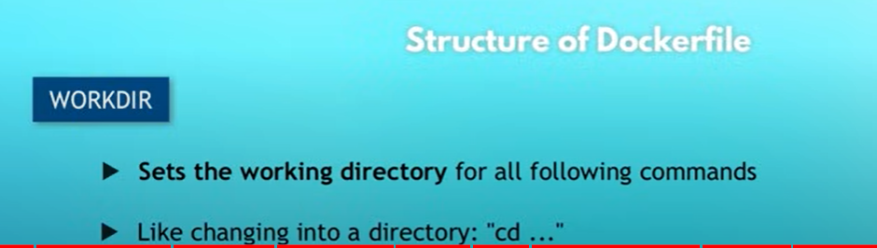

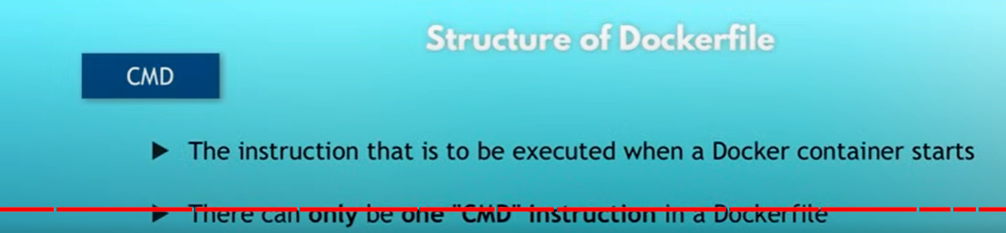

**Dockerfile**

FROM alpine:latest

COPY sdp-pymt-allinone-assembly /opt

WORKDIR /opt

# Update package lists and install necessary packages

RUN apk update && \

    apk add --no-cache curl && \

    rm -rf /var/cache/apk/*

# Download and install JDK 17

RUN curl -fsSL https://download.java.net/java/GA/jdk17/0d483333a00540d886896bac774ff48b/35/GPL/openjdk-17_linux-x64_bin.tar.gz | tar xvz -C /usr/local

# Set JAVA_HOME environment variable

ENV JAVA_HOME /usr/local/jdk-17

# Add Java binary directory to the PATH

ENV PATH $PATH:$JAVA_HOME/bin

